Muhammad Sherjeel Akhtar
20p-0101
BCS: 5A

.
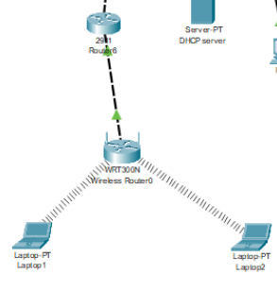
.

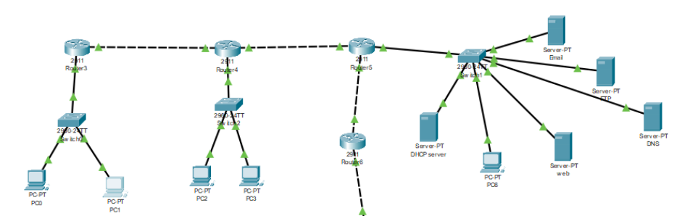
.
Starting Configuration:
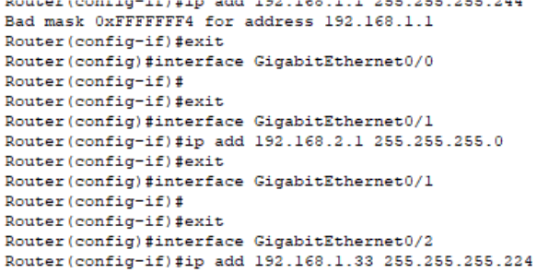
.
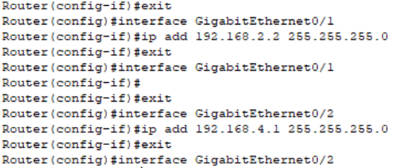
.
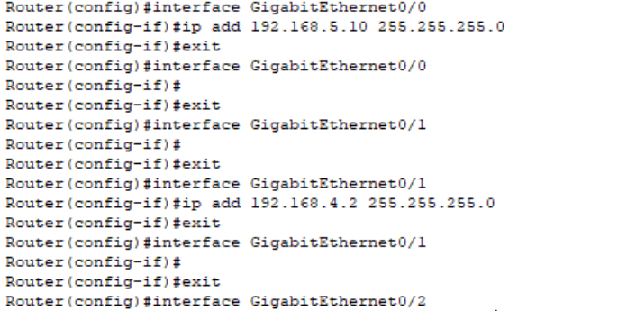
.
Wireless Routing:
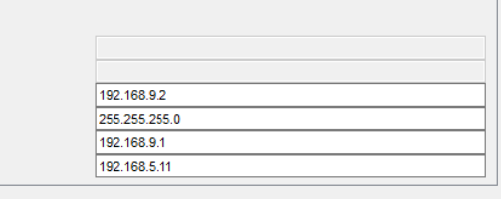
.
LAN:
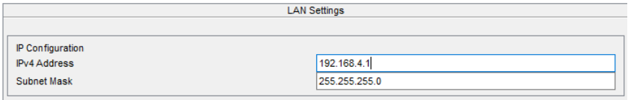
.
.Router-3 :
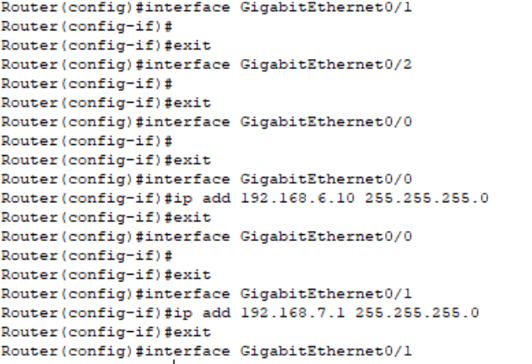
.

Email Conf:
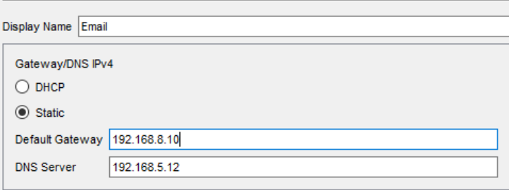
.
Email IP Configuration:
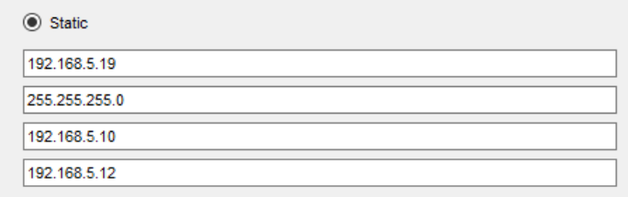
.
Mail Server:
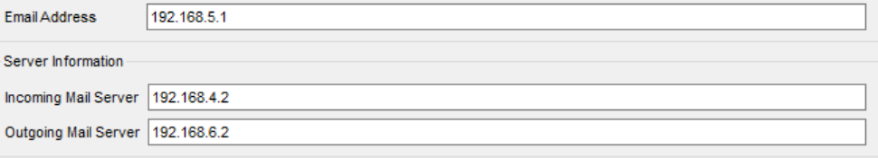
.
FTP Server Configuration:

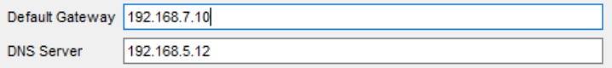
.
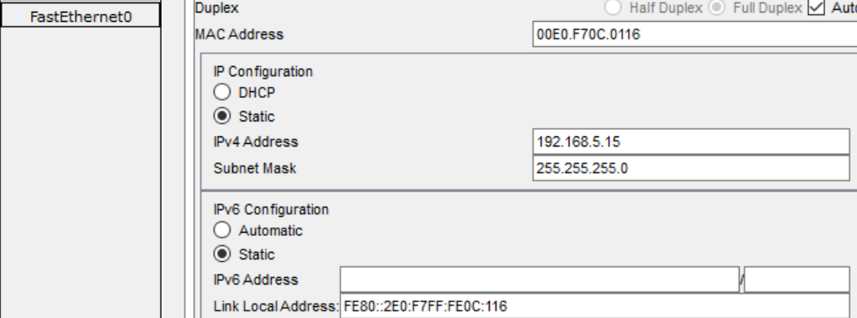
.
FTP IP Configuration:
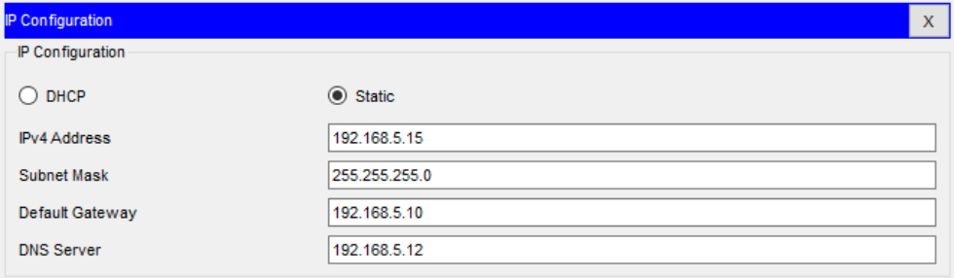
.
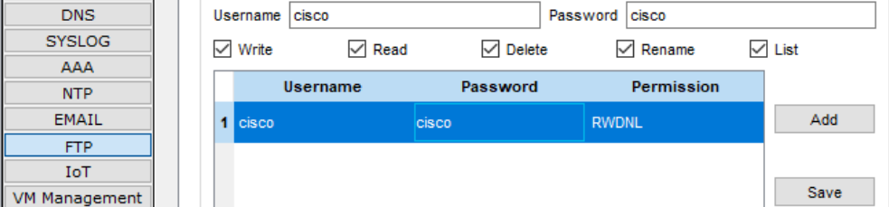
.
DNS Server Configuration:
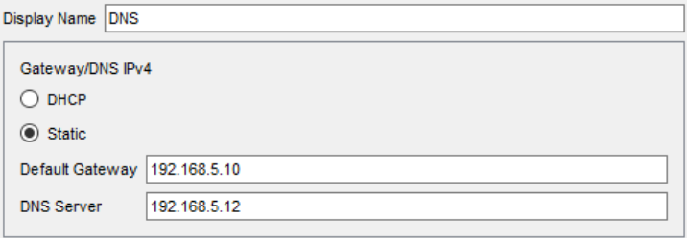
.
IP Configuration:
.
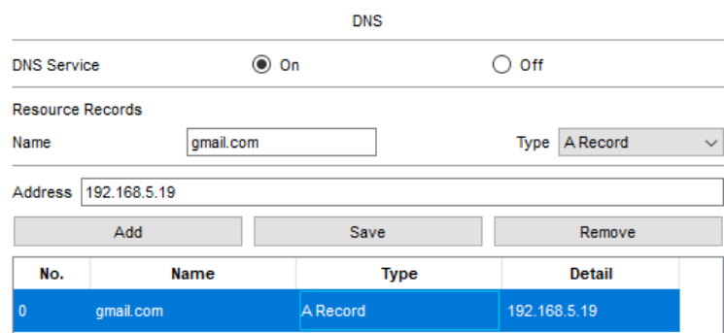
.
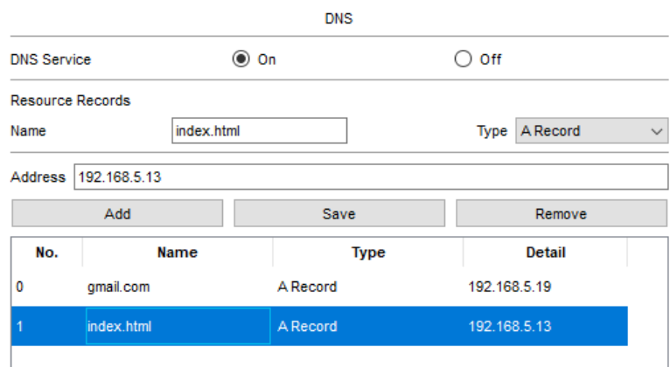
.
DNS IP Configuration:
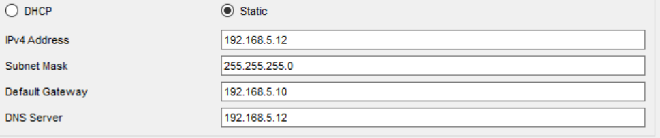
.
Web Server Configuration:
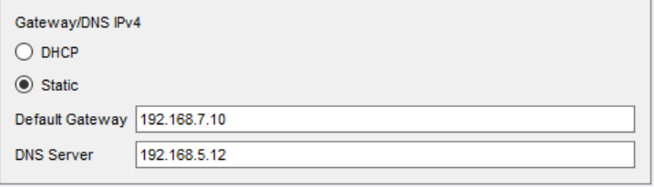
.
IP Configuration:
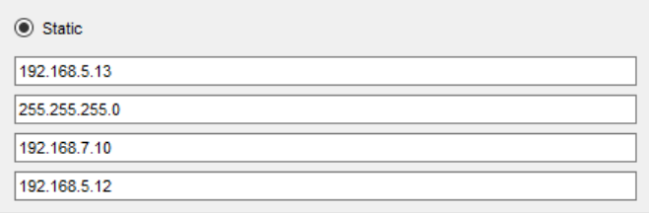
.
HTTP Configuration:
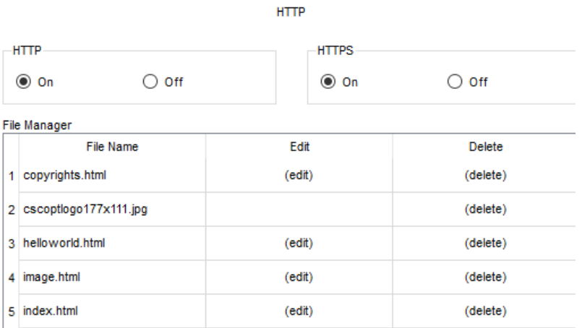
.
Addition In Web Server:
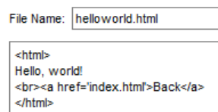
.

.

DHCP Server Configuration:
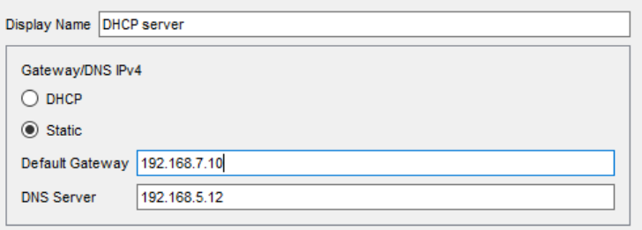
.
IP Configuration:

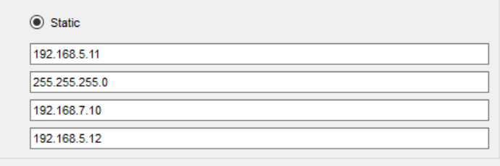
.
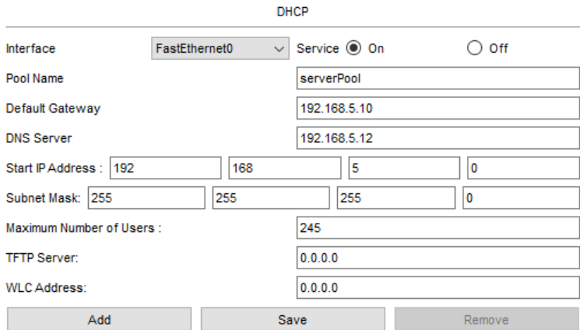
.
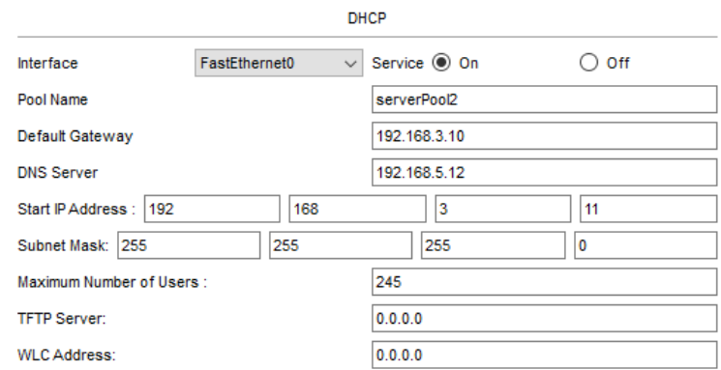
.
POOL 3:
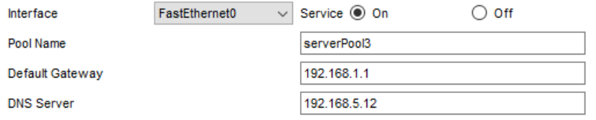
.
POOL 4:
.
POOL 5:
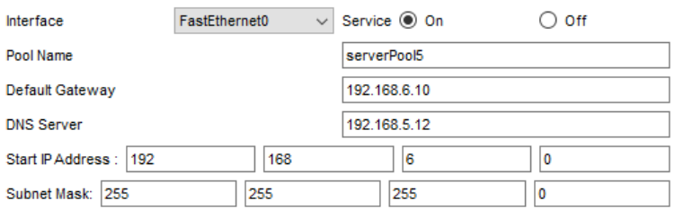
.
DHCP IP Assignment:
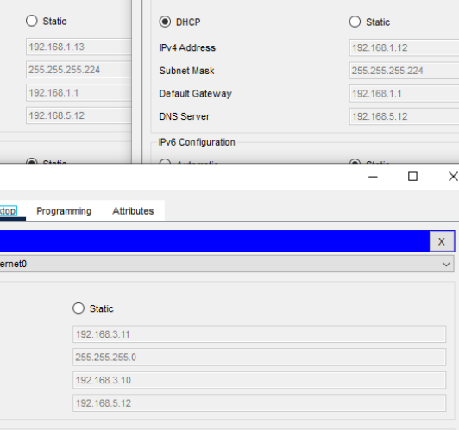
.
Conclusion:
You will receive a response after visiting the site.
-------------------------------

